Balancing your ideas and your sources

Too much information from sources

Acadia National Park is the northernmost and easternmost national park in the United States (Jefferson, 2012).  It is also the "oldest national park east of the Mississippi River" (Jefferson, 2012, p. 17).  Over the course of its history, its name has changed three times: from Sieur de Monts National Park in 1916, to Lafayette National Park in 1919, to Acadia National Park in 1929 (Jefferson, 2012). The park is located in the northern part of Maine near Bar Harbor (Maine Travel Board, 2017).

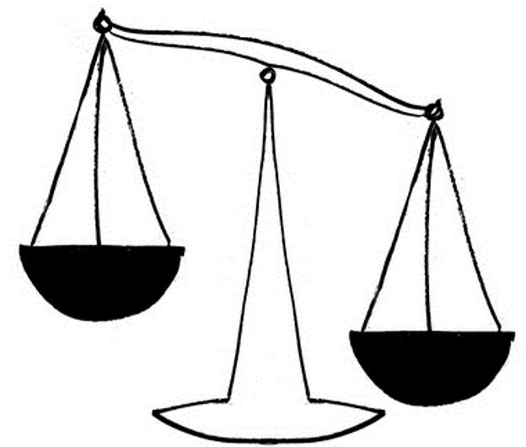

Acadia National Park is the northernmost and easternmost national park in the United States.

Over the course of its history, its name has changed three times: from Sieur de Monts National Park in 1916, to Lafayette National Park in 1919, to Acadia National Park in 1929.

It is also the "oldest national park east of the Mississippi River."

The park is located in the northern part of Maine near Bar Harbor.

Your ideas

**Information from   
sources**

**MORE**

**The right balance between your ideas and information from sources**

One of the most well-known national parks is Acadia National Park, near Bar Harbor, Maine. A unique characteristic of Acadia is its location: it is the northernmost and easternmost national park in the United States (Jefferson, 2012).  Acadia has another unique characteristic as well. It is the "oldest national park east of the Mississippi River" (Jefferson, 2012, p. 17).  It has had several names over the years, reflecting the history of the area. Originally called Sieur de Monts National Park after the 17th century French nobleman who governed the French colonies, its name was changed to Lafayette National Park in 1919, and then to Acadia National Park in 1929 (Jefferson, 2012).

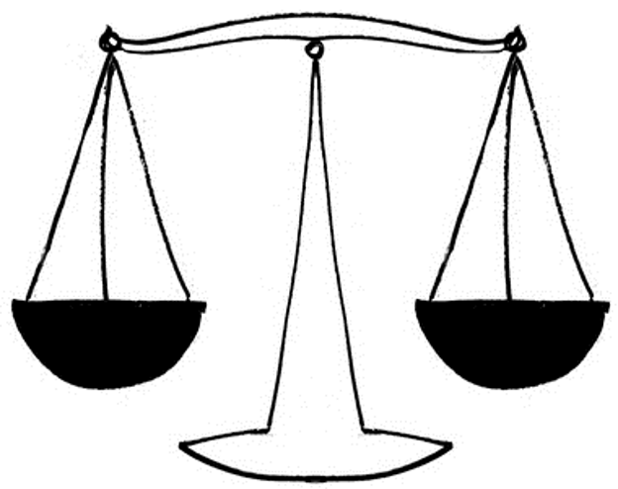

Acadia has another unique characteristic as well.

One of the most well-known national parks is Acadia National Park, near Bar Harbor, Maine. A unique characteristic of Acadia is its location:

It is the northernmost and easternmost national park in the United States

It is the "oldest national park east of the Mississippi River.”

It has had several names over the years, reflecting the history of the area.

Originally called Sieur de Monts National Park after a 17th century French nobleman who governed the French colonies, its name was changed to Lafayette National Park in 1919, and then to Acadia National Park in 1929.

Your ideas

**Information from sources**